Multiple Linear Regression (MLR) is a statistical technique used to model the relationship between a dependent variable and multiple independent (predictor) variables. In simple terms, it extends the concept of simple linear regression by using more than one predictor to make a prediction.
Here’s a breakdown of the concept from an interview perspective:
- Definition: Multiple Linear Regression tries to find a linear relationship between one dependent variable YYY and two or more independent variables X1,X2,…,XnX_1, X_2, \dots, X_nX1​,X2​,…,Xn​. The equation for an MLR model is:
Y=β0+β1X1+β2X2+⋯+βnXn+ϵY = \beta_0 + \beta_1 X_1 + \beta_2 X_2 + \dots + \beta_n X_n + \epsilonY=β0​+β1​X1​+β2​X2​+⋯+βn​Xn​+ϵ
where:
  - YYY: Dependent variable (the outcome we want to predict).
  - X1,X2,…,XnX_1, X_2, \dots, X_nX1​,X2​,…,Xn​: Independent variables (predictors).
  - β0\beta_0β0​: Intercept, the value of YYY when all XXX variables are zero.
  - β1,β2,…,βn\beta_1, \beta_2, \dots, \beta_nβ1​,β2​,…,βn​: Coefficients representing the change in YYY for a one-unit change in each XXX, holding other variables constant.
  - ϵ\epsilonϵ: Error term, representing unexplained variance.
- Objective: The main goal of MLR is to estimate the coefficients β1,β2,…,βn\beta_1, \beta_2, \dots, \beta_nβ1​,β2​,…,βn​ so that the model best fits the data, usually done by minimizing the sum of squared residuals (least squares method).
- Assumptions:
  - Linearity: The relationship between the dependent and independent variables is linear.
  - Independence: Observations are independent of each other.
  - Homoscedasticity: Constant variance of residuals (errors).
  - Normality of Residuals: Residuals should follow a normal distribution (especially important for inference).
  - No Multicollinearity: Independent variables should not be highly correlated.
- Interpretation: Each coefficient in MLR (like β1,β2\beta_1, \beta_2β1​,β2​) tells us how much the dependent variable YYY is expected to increase or decrease when the corresponding independent variable increases by one unit, holding other variables constant.
- Evaluation Metrics:
  - R-squared ( R2R^2R2 ): Explains the proportion of variance in the dependent variable explained by the independent variables.
  - Adjusted R-squared: Adjusts R2R^2R2 for the number of predictors, more useful in MLR as it accounts for potentially irrelevant predictors.
  - Mean Squared Error (MSE) or Root Mean Squared Error (RMSE): Measures average squared deviation or error of predictions.
- Applications: MLR is widely used in fields like economics, finance, marketing, and engineering for predictive analysis, such as predicting sales based on advertising spend, predicting stock prices, and forecasting demand.
- Limitations:
  - Sensitive to outliers, which can skew results.
  - Multicollinearity among predictors can make the model unstable.
  - Assumes a linear relationship, which may not always be true in real-world scenarios.
- Example: In predicting house prices, YYY could be the price of the house, and the predictors X1,X2,…X_1, X_2, \dotsX1​,X2​,… might include the square footage, number of bedrooms, and proximity to amenities. Multiple Linear Regression would help estimate how each factor contributes to the price.

Logistic Regression is a popular supervised learning algorithm primarily used for binary classification tasks. Despite its name, logistic regression is actually a classification algorithm rather than a regression one.
Here’s how to explain it from an interview perspective:
- Objective: Logistic Regression predicts the probability that an input belongs to a certain class. It’s mainly used when the target variable is categorical, typically binary (0 or 1, yes or no, spam or not spam).
- How It Works:
  - Logistic Regression estimates the probability of the target belonging to a certain class (usually “1”) by applying the logistic (sigmoid) function to a linear combination of the input features.
  - The sigmoid function squashes any input into a range between 0 and 1, making it suitable for probability outputs: Probability=σ(z)=11+e−z\text{Probability} = \sigma(z) = \frac{1}{1 + e^{-z}}Probability=σ(z)=1+e−z1​ where z=β0+β1X1+β2X2+⋯+βnXnz = \beta_0 + \beta_1X_1 + \beta_2X_2 + \dots + \beta_nX_nz=β0​+β1​X1​+β2​X2​+⋯+βn​Xn​, and β\betaβ values are coefficients for the predictors.
- Decision Boundary:
  - The output of the sigmoid function is a probability. By setting a threshold (typically 0.5), the model classifies instances into classes. For example, if the predicted probability is above 0.5, the instance might be classified as “1,” and otherwise as “0.”
- Training Process:
  - Logistic Regression uses a technique called Maximum Likelihood Estimation (MLE) to find the coefficients β\betaβ that maximize the likelihood of predicting the observed data correctly.
  - Gradient Descent is commonly used to iteratively update coefficients and find the best fit.
- Advantages:
  - Simple and Interpretable: Logistic Regression is easy to implement and interpret since the output is straightforward and probabilities can be useful for understanding confidence.
  - Efficient: Works
  - .
  - Feature Selection: By examining the coefficient values, one can interpret the significance of different features in predicting the target class.
- Limitations:
  - Linear Decision Boundary: Logistic Regression assumes a linear relationship between the independent variables and the log-odds of the outcome, making it unsuitable for non-linear problems without transformations or feature engineering.
  - Sensitive to Outliers: Outliers can affect the performance of Logistic Regression.
  - Binary Limitation: By default, it handles only binary classification, though multiclass problems can be tackled with extensions like One-vs-Rest or One-vs-One.
- Evaluation Metrics:
  - Common evaluation metrics for Logistic Regression include accuracy, precision, recall, F1-score, and AUC-ROC curve (for assessing the model’s performance at different classification thresholds).
- Applications:
  - Logistic Regression is widely used in applications where a binary outcome is needed, like spam detection, disease diagnosis, credit scoring, marketing campaign responses, and customer churn prediction.
- Example: Suppose we want to predict whether a customer will make a purchase (1) or not (0) based on features like age, income, and browsing history. Logistic Regression can estimate the probability of a purchase for each customer, helping decide who may be more likely to convert.
In short, Logistic Regression is valued for its simplicity, interpretability, and effectiveness in binary classification problems, making it a staple for many business applications where probability-based decisions are beneficial.
A Confusion Matrix is a performance evaluation tool used for classification models to show the actual versus predicted classifications. It provides insight into not only how accurate a model is but also where it might be making errors, giving a more granular view of performance than accuracy alone.
Components of a Confusion Matrix:
For a binary classification, the confusion matrix has four values:
 | Predicted Positive | Predicted Negative
Actual Positive | True Positives (TP) | False Negatives (FN)
Actual Negative | False Positives (FP) | True Negatives (TN)
Each term has a specific meaning:
- True Positives (TP): Correctly predicted positive cases (actual positive and predicted positive).
- False Positives (FP): Incorrectly predicted positive cases (actual negative, but predicted as positive). Also known as a "Type I error."
- True Negatives (TN): Correctly predicted negative cases (actual negative and predicted negative).
- False Negatives (FN): Incorrectly predicted negative cases (actual positive, but predicted as negative). Also known as a "Type II error."
Key Metrics Derived from a Confusion Matrix:
From the values in the confusion matrix, several important performance metrics can be calculated:
- Accuracy:
  - Measures the overall correctness of the model.
  - Formula: (TP+TN)/(TP+TN+FP+FN)(TP + TN) / (TP + TN + FP + FN)(TP+TN)/(TP+TN+FP+FN)
- Precision (Positive Predictive Value):
  - Indicates how many of the predicted positive cases were actually positive.
  - Formula: TP/(TP+FP)
- Recall (Sensitivity or True Positive Rate):
  - Measures how well the model captures all actual positive cases.
  - Formula: TP/(TP+FN)
- Specificity (True Negative Rate):
  - Measures the model’s ability to identify negative cases correctly.
  - Formula: TN/(TN+FP)
- F1 Score:
  - The harmonic mean of Precision and Recall, balancing both metrics.
  - Formula: 2×(Precision×Recall)/(Precision+Recall)2 \times (Precision \times Recall) / (Precision + Recall)2×(Precision×Recall)/(Precision+Recall)
Example of a Confusion Matrix:
Suppose we have a binary classification model that predicts whether an email is spam or not, and we get the following confusion matrix:
 | Predicted Spam | Predicted Not Spam
Actual Spam | 40 (TP) | 10 (FN)
Actual Not Spam | 5 (FP) | 45 (TN)
- True Positives (TP) = 40 (Spam emails correctly classified as spam)
- False Negatives (FN) = 10 (Spam emails incorrectly classified as not spam)
- False Positives (FP) = 5 (Not spam emails incorrectly classified as spam)
- True Negatives (TN) = 45 (Not spam emails correctly classified as not spam)
Calculated Metrics:
- Accuracy = (40+45)/(40+45+5+10)=85(40 + 45) / (40 + 45 + 5 + 10) = 85%(40+45)/(40+45+5+10)=85
- Precision = 40/(40+5)=0.8940 / (40 + 5) = 0.8940/(40+5)=0.89
- Recall = 40/(40+10)=0.840 / (40 + 10) = 0.840/(40+10)=0.8
- F1 Score = 2×(0.89×0.8)/(0.89+0.8)≈0.842 \times (0.89 \times 0.8) / (0.89 + 0.8) ≈ 0.842×(0.89×0.8)/(0.89+0.8)≈0.84
Interpretation of the Confusion Matrix:
The confusion matrix and derived metrics help you analyze where the model is performing well and where it is making mistakes. For example:
- High Precision, Lower Recall: Model is conservative in predicting positives but is likely accurate when it does.
- High Recall, Lower Precision: Model captures most positives but may have many false positives.
- Balanced F1 Score: Useful when a balance between precision and recall is essential.
When to Use a Confusion Matrix:
A confusion matrix is essential for classification tasks, particularly where:
- You want to analyze the types of errors (false positives and false negatives).
- The dataset is imbalanced, and accuracy alone doesn’t provide enough information (e.g., fraud detection or disease diagnosis).
- Metrics like Precision, Recall, and F1 Score are critical for the problem at hand.

Summary:
The Confusion Matrix is a powerful tool in model evaluation, especially for classification tasks. It helps break down the model's performance in terms of true positives, false positives, true negatives, and false negatives, enabling calculation of metrics like Precision, Recall, and F1 Score. This level of detail provides a better understanding of the model's strengths and weaknesses, especially in cases where simple accuracy may be misleading.
Bias and variance are fundamental concepts in machine learning that explain the sources of error in a model’s predictions. Together, they contribute to the Bias-Variance Tradeoff, which helps guide model complexity to improve model performance and generalization.
Here’s how to explain Bias vs. Variance from an interview perspective:

1. Bias:
- Definition: Bias is the error that results from overly simplistic assumptions in the learning algorithm. High bias occurs when a model is too simple to capture the underlying patterns in the data.
- Impact: High bias leads to underfitting, where the model fails to capture the complexity of the data and makes inaccurate predictions on both the training and test datasets.
- Example: Imagine a linear regression model trying to fit data with a quadratic relationship. A straight line is unlikely to capture the curvature, resulting in high bias and poor predictions.
- Key Point: Bias measures how closely the model’s predictions match the true values. A model with high bias is likely to ignore relevant patterns in the data.
2. Variance:
- Definition: Variance is the error that results from excessive sensitivity to small fluctuations in the training dataset. High variance occurs when a model is too complex and fits not only the underlying pattern but also the noise in the data.
- Impact: High variance leads to overfitting, where the model performs well on training data but poorly on new, unseen data, as it has “memorized” the training set rather than generalizing from it.
- Example: Consider a high-degree polynomial regression model that perfectly fits every point in a dataset. It’s likely to produce erratic predictions on test data due to overfitting.
- Key Point: Variance measures how much model predictions vary with different training data. A model with high variance will be overly flexible and not generalize well to new data.

3. Bias-Variance Tradeoff:
- Goal: Achieving a balance between bias and variance is key to building a model that generalizes well. The tradeoff is that reducing one often increases the other.
- Tradeoff:
  - A high-bias, low-variance model (e.g., a simple model like linear regression) might underfit the data, missing important patterns but being stable across different datasets.
  - A low-bias, high-variance model (e.g., a complex model like a deep neural network) might overfit the data, capturing too much noise, and failing to generalize well.
- Ideal Model: The best model is one with a balanced bias and variance, which captures patterns in the data without overfitting.
4. Visualizing Bias and Variance:
- A common analogy is the dartboard visualization:
  - High Bias, Low Variance: Darts are clustered together but far from the bullseye—consistent but inaccurate (underfitting).
  - Low Bias, High Variance: Darts are spread out around the bullseye—some are accurate, but predictions vary widely (overfitting).
  - Low Bias, Low Variance: Darts are clustered around the bullseye—accurate and consistent, representing the ideal model.
  - 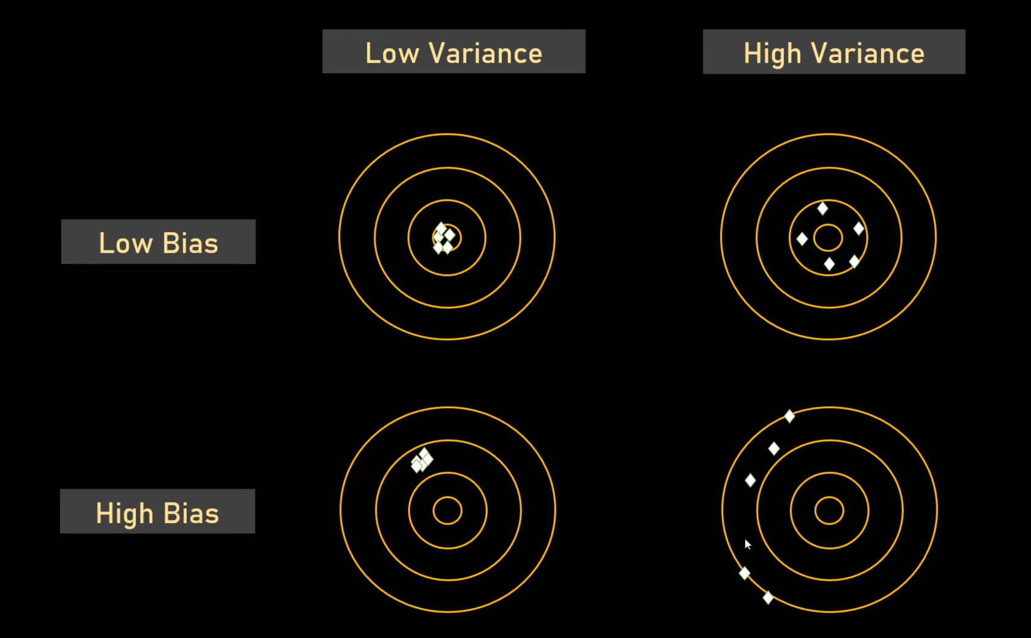

5. Examples in Machine Learning Models:
- High Bias Models: Linear regression, Naive Bayes, and other simpler models are prone to high bias but have lower variance.
- High Variance Models: Decision trees, k-nearest neighbors, and neural networks are flexible and can easily overfit, leading to high variance if not controlled (e.g., using pruning in decision trees or regularization in neural networks).
6. Reducing Bias and Variance:
- Reducing Bias: Use a more complex model, add more features, or apply feature engineering.
- Reducing Variance: Simplify the model, use techniques like cross-validation, regularization (e.g., Lasso, Ridge), or ensemble methods like bagging and boosting.
- Reasons for overfit
  - Poor model, Hyperparameter selections- Better model & hyperpaatrmeters selections
  - Insufficient training data- suffienct training data
  - Poor feature selection-careful feature selection
  - Inadequate validation-adequate validation using k fold
  - Lack of regularization- apply regularization

Reasons for underfit
- Model is too simple
- Insuffient data points
- Insuffiecint features
- Insuffiecinent training time
- Inadrqaute validation
- Excessive regularization

Summary:
- Bias leads to underfitting due to oversimplification, while variance leads to overfitting due to excessive model flexibility.
- The bias-variance tradeoff is essential for selecting the right model complexity to achieve good generalization on new data.

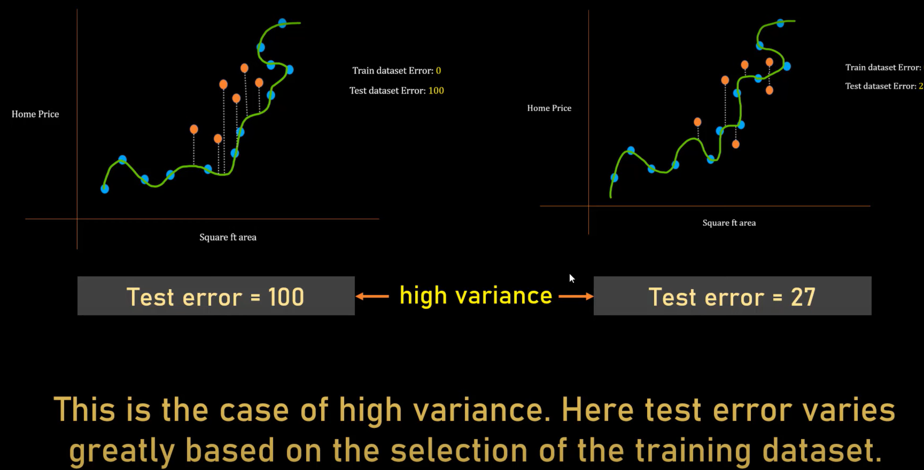

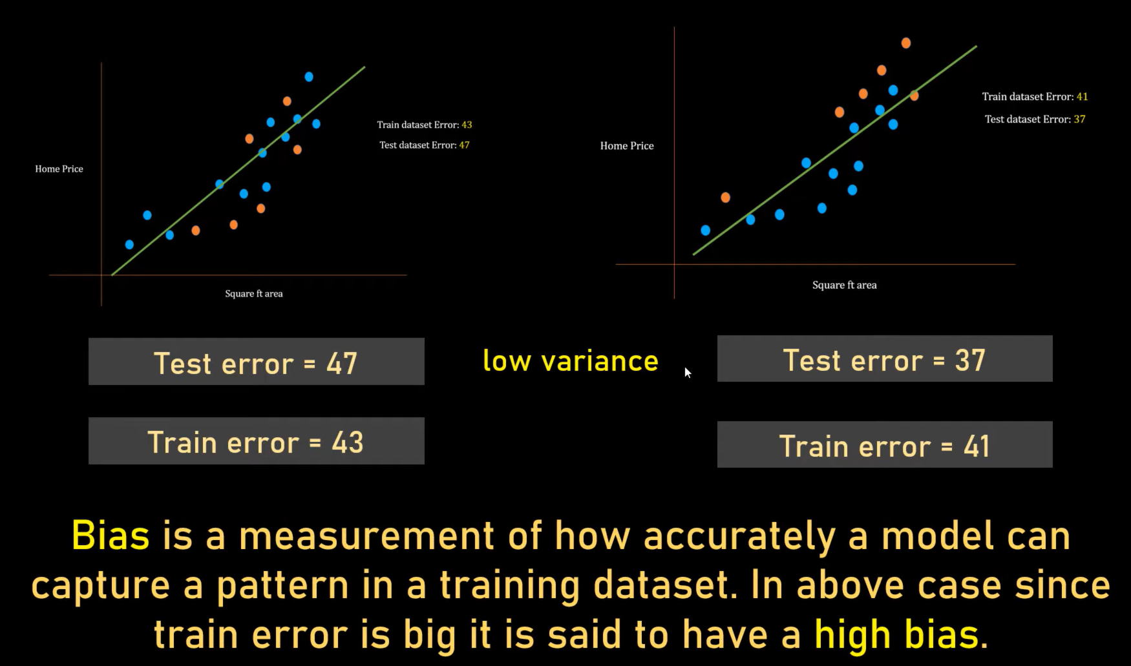
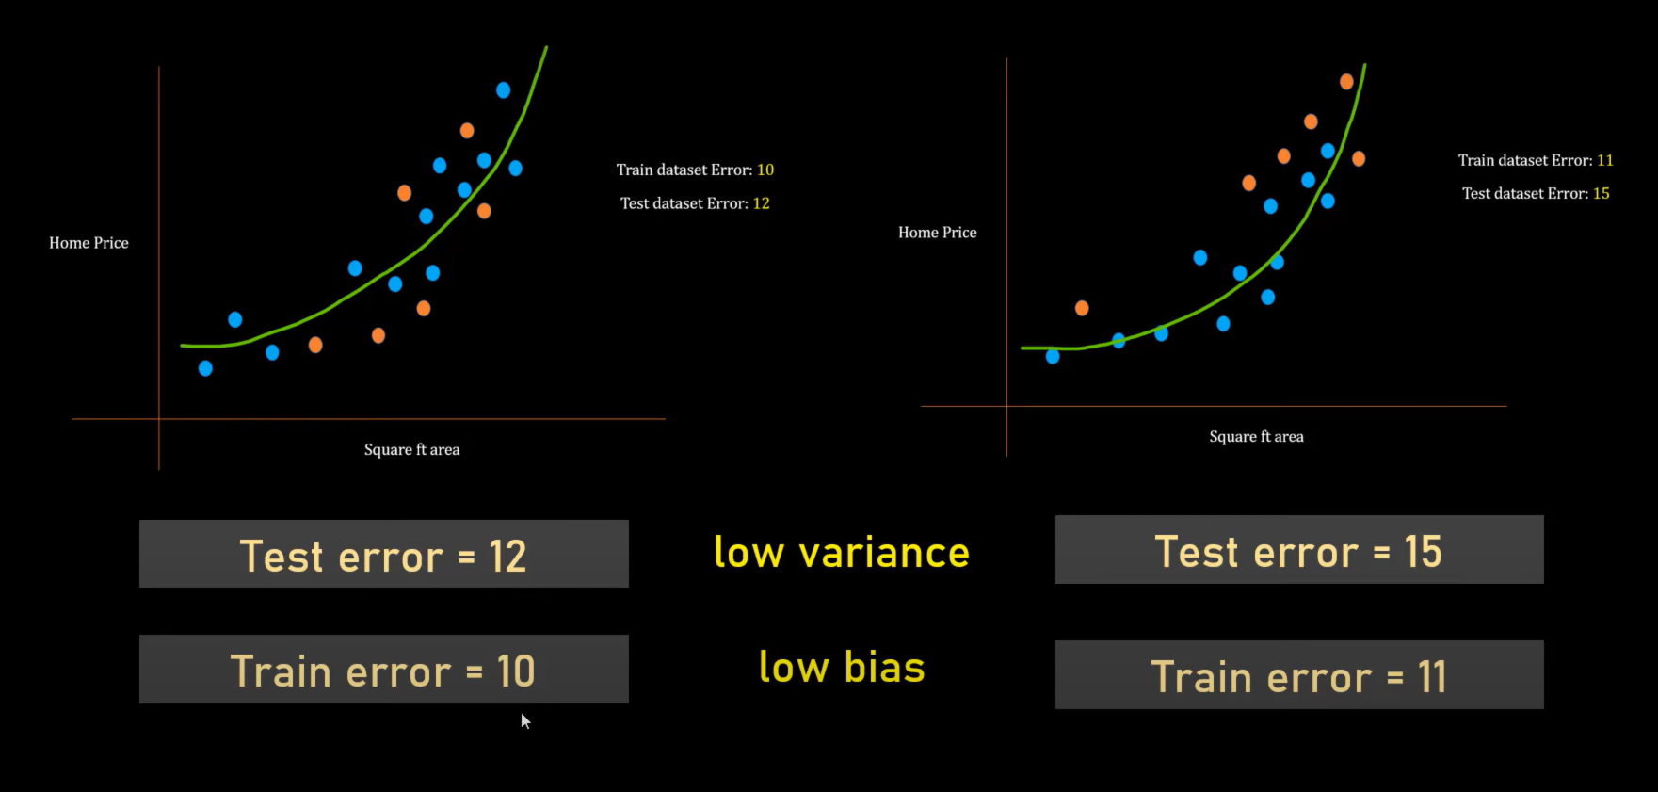
How do you handle Bias-Variance Tradeoff?”
You can answer:
“Bias-Variance Tradeoff is the balance between underfitting and overfitting. To reduce high bias, we increase model complexity, add features, or reduce regularization. To reduce high variance, we use techniques like regularization, cross-validation, feature selection, more training data, pruning, and early stopping. The goal is to achieve good generalization on unseen data.”
Q. Which is worse: bias or variance?
Depends on use case.
But generally:
- Slightly higher bias is acceptable
- High variance is dangerous in production

Q. Why does regularization reduce variance?
Because it prevents model weights from becoming excessively large.

Q. How does cross-validation help?
It evaluates model performance on unseen folds,
helping select optimal complexity.

Q. Why does adding more data reduce variance?
Model becomes less sensitive to noise.
L1 and L2 Regularization are techniques used to prevent overfitting in machine learning models, particularly in linear regression. They add a penalty to the loss function based on the magnitude of the model’s coefficients, thereby shrinking some of the weights and helping generalize the model to new data.
Here’s a breakdown of L1 (Lasso) and L2 (Ridge) Regularization from an interview perspective:

1. Objective of Regularization:
- Reduce Overfitting: Regularization controls model complexity by adding a penalty to the model’s loss function, discouraging the model from assigning large weights to any feature.
- Improve Generalization: By shrinking the coefficients, regularization improves the model’s ability to perform well on new, unseen data.
2. L1 Regularization (Lasso Regression):
- Definition: L1 regularization (used in Lasso Regression) adds a penalty equal to the absolute value of the magnitude of coefficients.
- Loss Function: In Lasso, the loss function with L1 regularization is: Loss=MSE+λ∑∣wi∣
  - Loss=MSE+λ∑∣wi​∣ where λ\lambdaλ is the regularization parameter, and wi are the model coefficients.
- Effect on Weights:
  - L1 regularization can set some coefficients to zero, effectively removing certain features from the model. This makes Lasso useful for feature selection.
- Interpretation: The model is sparse, as Lasso selects a subset of features, which can be helpful in high-dimensional data where many features may be irrelevant.
3. L2 Regularization (Ridge Regression):
- Definition: L2 regularization (used in Ridge Regression) adds a penalty equal to the square of the magnitude of coefficients.
- Loss Function: In Ridge, the loss function with L2 regularization is: Loss=MSE+λ∑wi2\text{Loss} = \text{MSE} + \lambda \sum w_i^2Loss=MSE+λ∑wi2​
- Effect on Weights:
  - L2 regularization penalizes large coefficients by forcing them closer to zero, but it does not set any coefficients exactly to zero. It helps with shrinkage but not with feature selection.
- Interpretation: Ridge helps reduce the influence of features with high variance, providing more stable coefficient estimates.
4. Difference between L1 and L2 Regularization:
- Penalization Type: L1 uses absolute values (|w|), while L2 uses squares of weights (w²).
- Feature Selection: L1 can drive coefficients to zero, effectively excluding some features (sparse model). L2 reduces coefficients but does not set them to zero.
- Interpretability: Lasso can lead to simpler models with fewer predictors, making it useful for interpretability. Ridge retains all features, which can be beneficial when all variables carry some predictive power.
5. Combined L1 and L2 Regularization (Elastic Net):
- Definition: Elastic Net is a combination of L1 and L2 regularization. It’s useful when there are correlations among predictors because it can balance feature selection (L1) and shrinkage (L2).
- Loss Function: Loss=MSE+α(λ1∑∣wi∣+λ2∑wi2)\text{Loss} = \text{MSE} + \alpha (\lambda_1 \sum |w_i| + \lambda_2 \sum w_i^2)Loss=MSE+α(λ1​∑∣wi​∣+λ2​∑wi2​) where α\alphaα balances the mix of L1 and L2 regularization.
- Application: Often used in situations where Lasso or Ridge alone may not be optimal, such as when you have many correlated features.
6. Applications of L1 and L2 Regularization:
- Lasso: Used in high-dimensional datasets where feature selection is necessary, such as text processing or gene selection in biology.
- Ridge: Used when all features are expected to have an effect on the response variable, especially in multicollinearity cases.
- Elastic Net: Preferred when dealing with highly correlated features or when neither Lasso nor Ridge performs well alone.
7. Choosing the Regularization Parameter (λ\lambdaλ):
- Hyperparameter Tuning: The regularization parameter λ\lambdaλ controls the strength of the penalty. It can be tuned using methods like cross-validation.
- Effect of λ\lambdaλ:
  - A small λ\lambdaλ leads to less regularization, and the model may overfit.
  - A large λ\lambdaλ leads to stronger regularization, possibly underfitting the model.

In summary, L1 (Lasso) and L2 (Ridge) regularization are essential tools for controlling model complexity. L1 helps with feature selection by setting some coefficients to zero, while L2 helps with shrinkage without excluding features. These methods are widely used to improve model generalization, especially with high-dimensional or multicollinear data.

A Decision Tree is a supervised machine learning algorithm used for both classification and regression tasks. It works by splitting data into branches at decision points, which creates a tree-like structure that helps in making decisions based on the features of the input data.
From an interview perspective, here’s a concise way to explain it:
- Structure: A decision tree has nodes that represent decisions, branches that represent the outcomes of decisions, and leaf nodes that represent the final prediction or outcome. The top-most node is the root, while terminal nodes are the leaves.
- Splitting Criteria: Decision trees use splitting criteria to divide data into subsets at each node. The most common splitting criteria are:
  - Gini Index: Measures the "impurity" or likelihood of incorrect classification of a new data point.
  - Entropy/Information Gain: Used in ID3 (Iterative Dichotomiser 3) and C4.5 algorithms to maximize information gain.
  - Variance Reduction: Used in regression trees to minimize variance in the target variable.
- Interpretability: Decision trees are popular because they provide a clear, intuitive way to understand how decisions are made and are easy to visualize. The tree structure makes it easy to follow the decision process.
- Overfitting: Decision trees can be prone to overfitting, especially when they are too deep or have too many branches. To counter this, techniques like pruning (removing branches that add little value) and setting depth limits are used.
- Advantages:
  - Simple to understand and interpret.
  - Handles both numerical and categorical data.
  - Non-parametric, so it doesn’t assume a particular data distribution.
- Disadvantages:
  - Prone to overfitting without pruning.
  - Can be unstable, as small changes in data can lead to different splits.
- Applications: Decision trees are widely used in scenarios such as customer segmentation, risk assessment, fraud detection, and medical diagnosis, where interpretability is crucial.
- Popular Algorithms: Some notable algorithms that use decision trees are:
  - CART (Classification and Regression Trees) – Used in scikit-learn’s DecisionTreeClassifier and DecisionTreeRegressor.
  - ID3, C4.5, and C5.0 – For classification tasks.
  - Random Forests and Gradient Boosting – Ensemble methods that use multiple decision trees to improve accuracy.
Support Vector Machines (SVM) is a powerful supervised machine learning algorithm used for classification and regression tasks. It’s particularly popular for classification problems because of its effectiveness in high-dimensional spaces and ability to create a clear margin of separation between classes.
Here’s a breakdown of SVM from an interview perspective:
- Objective: SVM aims to find a hyperplane (decision boundary) that best separates classes in the data. The best hyperplane is one that maximizes the margin between the classes, where the margin is defined as the distance between the hyperplane and the nearest data points of each class. These nearest points are called support vectors.
- How It Works:
  - In a 2D space, the hyperplane is a line, while in higher dimensions, it’s a plane or a hyperplane.
  - SVM tries to maximize the margin around the hyperplane so that it can classify new data points with the greatest accuracy and separation between classes.
  - The algorithm focuses only on the support vectors (points closest to the hyperplane) because they are the most challenging points to classify and thus define the optimal margin.
- Mathematics Behind SVM:
  - SVM tries to minimize the error while maximizing the margin. This is formulated as an optimization problem where the goal is to maximize the distance between classes while penalizing misclassification.
  - In cases where data isn’t linearly separable, SVM uses a soft margin, allowing for some misclassification but minimizing it as much as possible.
- Kernel Trick:
  - SVM can handle non-linear classification tasks by using a kernel trick, which maps the data into a higher-dimensional space where a linear separator can be applied.
  - Common kernels include:
    - Linear Kernel: For linearly separable data.
    - Polynomial Kernel: Useful for polynomial boundaries.
    - Radial Basis Function (RBF) or Gaussian Kernel: Suitable for complex and non-linear boundaries.
- Advantages:
  - Effective in high-dimensional spaces and with a large number of features.
  - Uses only support vectors, making it memory-efficient.
  - Robust to overfitting, especially in high-dimensional space, due to the regularization parameter that controls margin size.
- Limitations:
  - SVM can be computationally intensive, especially with large datasets.
  - Choice of kernel and tuning parameters can be tricky, requiring time and expertise.
  - Not ideal for datasets with many noisy features or overlapping classes, as it may struggle to find a clear separation.
- Evaluation Metrics:
  - SVM is typically evaluated using classification metrics like accuracy, precision, recall, F1-score, and confusion matrix for classification tasks.
- Applications: SVMs are used in text classification, image recognition, face detection, medical diagnosis, and bioinformatics, especially when the dataset is high-dimensional and needs a robust model.
- Example: Imagine a dataset of emails classified as “spam” or “not spam” based on features like word frequency, subject line, and length. SVM can draw an optimal boundary that distinguishes these classes effectively, even if there’s high dimensionality, such as thousands of words or features used for classification.
In essence, SVM is valued for its capability to handle complex, high-dimensional data and draw a robust decision boundary even in challenging cases, which is why it's popular in domains where accuracy and classification clarity are critical.
Random Forest is an ensemble learning method that combines multiple decision trees to create a stronger, more robust model. It is widely used for both classification and regression tasks due to its flexibility, accuracy, and ability to handle a variety of data types.
Here’s how to explain Random Forest from an interview perspective:
- Objective: Random Forest aims to improve predictive accuracy and stability by combining the outputs of multiple decision trees. It addresses the issue of overfitting often seen in individual decision trees by averaging multiple trees’ results.
- How It Works:
  - A Random Forest model creates multiple decision trees, each trained on a different random subset of the original dataset. This technique is known as bootstrap aggregating or bagging.
  - For each tree, a random subset of features is selected at each split, adding further variability. This random feature selection helps each tree to capture different aspects of the data.
  - For classification, Random Forest aggregates results by using a majority vote among the trees; for regression, it averages the predictions of the trees.
- Why It’s Effective:
  - Reduction of Overfitting: By combining multiple trees, Random Forest reduces the risk of overfitting, which is common in single decision trees.
  - Robust to Noise: Random selection of features and data subsets makes the model less sensitive to outliers and noise in the data.
  - High Accuracy: Random Forest generally achieves higher accuracy than individual decision trees, especially in complex, high-dimensional datasets.
- Feature Importance:
  - Random Forest provides a measure of feature importance by evaluating the impact of each feature on reducing impurity across all trees. This can be useful for feature selection and understanding which features are most relevant to predictions.
- Advantages:
  - Versatile and Scalable: Performs well for both classification and regression, and can handle large datasets with high-dimensional features.
  - Handles Missing Values: Random Forest can handle missing values by using various techniques, such as averaging predictions.
  - Robust: Works well even if the underlying decision trees are weak learners, as the aggregation makes the final model strong.
- Limitations:
  - Computationally Intensive: Training many decision trees requires more memory and computational power, which may be challenging with large datasets.
  - Interpretability: While it’s easier to interpret than some black-box models, Random Forest is still less interpretable than a single decision tree.
- Evaluation Metrics:
  - For classification, typical metrics include accuracy, precision, recall, F1-score, and AUC-ROC.
  - For regression, metrics like Mean Squared Error (MSE) and Root Mean Squared Error (RMSE) are commonly used.
- Applications:
  - Random Forest is widely used in finance for credit scoring and risk assessment, in healthcare for predicting diseases, and in e-commerce for customer segmentation and recommendation systems.
- Example: Imagine building a Random Forest model to predict whether a loan applicant will default based on features like income, credit score, and employment history. Each decision tree will make a prediction, and the Random Forest will take a majority vote (classification) or average the predictions (regression) to provide a robust and accurate prediction.
In summary, Random Forest is a powerful and flexible ensemble learning technique that combines multiple decision trees for greater predictive accuracy, making it a top choice in many data science applications where interpretability is less critical than accuracy and robustness.
K-Fold Cross Validation is a model evaluation technique used to assess how well a machine learning model generalizes to unseen data. It’s especially useful for small datasets, where dividing data into separate training and testing sets might not be feasible.
Here’s how to explain K-Fold Cross Validation from an interview perspective:
- Objective: K-Fold Cross Validation aims to give a more reliable estimate of model performance by reducing variance in performance results, providing a more stable accuracy or error measure compared to a single train-test split.
- How It Works:
  - The dataset is split into K equal subsets (or "folds"). Each subset acts as a temporary holdout set, while the remaining K-1 folds serve as the training set.
  - The process repeats K times, each time using a different fold as the test set and the remaining K-1 folds as the training data.
  - After K iterations, the model’s performance is averaged across all folds to get a final performance estimate.
- Example:
  - In 5-Fold Cross Validation, the data is divided into five folds. The model is trained and tested five times, with each fold used once as the test set.
  - If the test accuracies across the folds are 80%, 82%, 79%, 83%, and 81%, the final model accuracy would be the average of these, i.e., 81%.
- Advantages:
  - Reduces Overfitting: By ensuring the model is tested on all parts of the data, K-Fold Cross Validation gives a more realistic estimate of its performance on unseen data.
  - More Reliable Metrics: Since all data points are used for both training and testing, it reduces the impact of data variance or bias from a single split.
  - Efficient Use of Data: Especially beneficial for small datasets, as it allows the entire dataset to contribute to training and testing.
- Parameter K:
  - Common choices for KKK are 5 or 10 because they offer a good trade-off between stability and computational efficiency.
  - Smaller K (like K=3) increases variance because fewer folds mean less training data per fold, while a larger K (like K=10 or K=20) can provide a more stable performance estimate but at a higher computational cost.
- Stratified K-Fold Cross Validation:
  - For classification tasks, especially when the class distribution is imbalanced, Stratified K-Fold Cross Validation is recommended. It ensures each fold has a similar proportion of each class, leading to more reliable performance estimates.
- Limitations:
  - Computationally Expensive: Since the model trains and evaluates K times, K-Fold Cross Validation can be computationally intensive, especially with large datasets or complex models.
  - Bias-Variance Trade-Off: Very high values of KKK may reduce bias but increase variance, as small test sets make performance estimates sensitive to data fluctuations.
- Applications:
  - Commonly used in hyperparameter tuning, model selection, and validating model robustness before deployment.
In summary, K-Fold Cross Validation is a robust technique for evaluating a model’s generalizability by leveraging all parts of the dataset, making it a popular choice for model validation in machine learning.
K-Means Clustering is an unsupervised machine learning algorithm used for clustering or grouping data points into distinct clusters based on their similarity. It’s one of the most popular clustering techniques because of its simplicity and efficiency.
Here’s how to explain K-Means Clustering from an interview perspective:
- Objective: The goal of K-Means is to partition the dataset into K clusters, where each data point belongs to the cluster with the nearest mean, also called the centroid. This minimizes the variance within clusters and maximizes the distance between clusters.
- How It Works:
  - Step 1: Initialize Centroids: Choose KKK random points from the dataset as initial centroids.
  - Step 2: Assign Data Points: Each data point is assigned to the closest centroid based on a distance metric, typically Euclidean distance.
  - Step 3: Update Centroids: Recalculate the centroid of each cluster by taking the mean of all data points in the cluster.
  - Step 4: Repeat: Steps 2 and 3 are repeated until the centroids no longer change significantly, or a pre-defined number of iterations is reached.
- Parameter K:
  - KKK, the number of clusters, is a user-defined parameter. Choosing the right number of clusters is important and often determined through techniques like the Elbow Method or Silhouette Score.
  - In the Elbow Method, the sum of squared distances between points and their cluster centroids is plotted against various values of KKK. The "elbow point" (where the curve bends) indicates an optimal value of KKK.
- Advantages:
  - Simple and Fast: K-Means is computationally efficient, even with large datasets.
  - Scalable: Works well with high-dimensional data and large datasets due to its relatively low computational cost.
  - Ease of Interpretation: Results in well-defined, compact clusters, making the output easy to interpret and visualize.
- Limitations:
  - Fixed K: Requires the number of clusters to be defined in advance, which may not be straightforward in many real-world problems.
  - Sensitive to Initialization: The initial choice of centroids can impact the results. To counter this, K-Means++ initialization is commonly used, which carefully selects initial centroids.
  - Assumes Spherical Clusters: K-Means assumes clusters are spherical and equally sized, making it less effective with irregularly shaped or imbalanced clusters.
  - Sensitive to Outliers: Outliers can distort centroids since K-Means uses mean distances.
- Applications:
  - K-Means is widely used in customer segmentation, image compression, document clustering, anomaly detection, and market segmentation.
- Example:
  - Imagine using K-Means to segment customers based on purchase history. Given features like total spend and frequency, K-Means can group customers into clusters representing different spending patterns (e.g., high spenders, low spenders), which can inform targeted marketing strategies.
- Evaluation:
  - K-Means clustering is typically evaluated using metrics like the Silhouette Score or Within-Cluster Sum of Squares (WCSS), which help assess the quality and cohesion of clusters.
In short, K-Means Clustering is a versatile and efficient algorithm for grouping data points into well-defined clusters, making it a valuable tool in various exploratory data analysis and segmentation tasks.
K-Nearest Neighbors (KNN) is a simple, non-parametric, supervised learning algorithm used for both classification and regression tasks. It’s often applied in classification problems due to its straightforward, intuitive approach, where predictions for new data points are made based on the similarity to nearby data points in the feature space.
Here’s how to explain K-Nearest Neighbors Classification from an interview perspective:
1. Objective:
- The goal of KNN classification is to classify a new data point based on its "neighbors," i.e., the nearby points in the training dataset. The new point is assigned to the class that is most common among its K-nearest neighbors.
2. How KNN Works:
- Step 1: Choose the number of neighbors, K.
- Step 2: For a new data point that needs to be classified, calculate the distance between this point and all points in the training data.
  - Distance Metrics: Common distance metrics include Euclidean distance (most widely used), Manhattan distance, and Minkowski distance. Euclidean distance is typically calculated as: d(p,q)=∑i=1n(pi−qi)2d(p, q) = \sqrt{\sum_{i=1}^{n} (p_i - q_i)^2}d(p,q)=i=1∑n​(pi​−qi​)2​ where ppp and qqq are two points in n-dimensional space.
- Step 3: Identify the K-nearest neighbors to the new data point, i.e., the K points in the training data with the smallest distances to the point.
- Step 4: Assign the new point to the most common class among these K neighbors.
3. Choosing the Value of K:
- Low K Value: If K is too small (e.g., 1), the model can be sensitive to noise and may overfit, as it will classify a point based on the closest single neighbor.
- High K Value: If K is too large, the model might underfit because the decision boundary becomes less flexible.
- Optimal K: Typically, K is chosen using cross-validation, and values like the square root of the total number of points are often a good starting point.
4. Advantages:
- Simple and Intuitive: KNN is easy to understand and implement, making it a good choice for initial explorations of datasets.
- No Training Phase: KNN is a lazy learner, meaning it doesn’t learn an explicit model. Instead, it stores the entire training dataset and makes predictions only when new data points are given.
- Adaptable to Multiclass Problems: KNN can easily handle multiclass classification problems by taking the majority vote among the nearest neighbors.
5. Limitations:
- Computationally Expensive: As KNN stores all training data and performs calculations for each new prediction, it can be slow with large datasets, especially if there are many features.
- Sensitive to Irrelevant Features and Scaling: KNN assumes all features contribute equally, so irrelevant features can mislead classification. Also, it’s important to scale the features (e.g., using standardization) as different scales can distort distance calculations.
- Curse of Dimensionality: As the number of features increases, distances between points become less meaningful, and KNN can struggle to classify effectively.
6. Applications:
- Image Recognition: KNN is often used in computer vision tasks, like handwriting recognition, where similar images are likely to belong to the same class.
- Recommendation Systems: Used in collaborative filtering to recommend items based on user similarity.
- Anomaly Detection: KNN can be applied to detect outliers or unusual patterns by identifying points with distant neighbors.
7. Example:
- Suppose you have a dataset of fruit, with features such as weight, color, and texture, and each fruit is labeled as either "apple," "banana," or "orange." Given a new fruit with specific features, KNN calculates the distance to other fruits in the dataset and assigns it to the most common class among the K nearest fruits.
8. Implementation:
- In Python, KNN can be implemented using libraries like scikit-learn:
python
Copy code
from sklearn.neighbors import KNeighborsClassifier
from sklearn.model_selection import train_test_split
from sklearn.preprocessing import StandardScaler
from sklearn.metrics import accuracy_score

# Assume we have features X and labels y
X_train, X_test, y_train, y_test = train_test_split(X, y, test_size=0.3, random_state=42)

# Scale the features
scaler = StandardScaler()
X_train = scaler.fit_transform(X_train)
X_test = scaler.transform(X_test)

# Initialize and train the model
model = KNeighborsClassifier(n_neighbors=5)
model.fit(X_train, y_train)

# Make predictions
y_pred = model.predict(X_test)
print("Accuracy:", accuracy_score(y_test, y_pred))
In summary, KNN Classification is a straightforward and interpretable algorithm that uses the similarity between data points to classify new data. It’s highly effective in many scenarios but can be limited by computational costs and sensitivity to irrelevant features, making feature scaling and dimensionality reduction crucial steps when working with KNN.
Principal Component Analysis (PCA) is a popular dimensionality reduction technique that simplifies complex, high-dimensional data by transforming it into a lower-dimensional space while retaining most of the original variability in the data. PCA is widely used for feature extraction, noise reduction, and visualizing high-dimensional datasets.
Here’s how to explain Principal Component Analysis (PCA) from an interview perspective:

1. Objective of PCA:
- Dimensionality Reduction: PCA reduces the number of features in a dataset by transforming it into a new set of uncorrelated features called principal components. Each principal component captures as much of the variance (information) in the original data as possible.
- Feature Extraction: Rather than discarding data, PCA combines features into components, retaining as much of the dataset’s information as possible.
2. How PCA Works:
- Standardize the Data: PCA requires that the data is scaled so that each feature contributes equally. This is done by standardizing each feature (mean of 0 and standard deviation of 1).
- Compute the Covariance Matrix: The covariance matrix is calculated to understand how features in the dataset vary together. This matrix reveals the relationships between features and highlights redundant information.
- Calculate Eigenvalues and Eigenvectors: Eigenvalues and eigenvectors of the covariance matrix are calculated. The eigenvectors indicate the direction of each principal component, and the eigenvalues indicate the amount of variance captured by each component.
- Rank and Select Principal Components: Principal components are ranked by their eigenvalues in descending order. The components with the highest eigenvalues are chosen to form the reduced feature set, as they capture the most variance.
- Transform the Data: The original data is projected onto the selected principal components, producing a lower-dimensional representation.
3. Key Concepts in PCA:
- Principal Components: New axes created by PCA are linear combinations of the original features. Each successive component is orthogonal to the previous one and captures the maximum remaining variance.
- Explained Variance: The proportion of total variance captured by each principal component. By retaining only components that explain a significant amount of variance, PCA reduces dimensionality while preserving information.
- Variance Retention: Often, a threshold (e.g., 95%) is set for the total explained variance to decide how many components to keep.
4. Advantages of PCA:
- Reduces Overfitting: By reducing the number of features, PCA can help reduce overfitting, especially in cases where the original feature space is very large.
- Improves Computational Efficiency: Reducing dimensionality decreases the computational cost, especially for algorithms sensitive to high dimensions.
- Visualization: For datasets with many features, PCA can reduce them to two or three dimensions, enabling visualization in 2D or 3D.
5. Limitations of PCA:
- Loss of Interpretability: Principal components are linear combinations of the original features, which can make it hard to interpret the meaning of each component.
- Linear Assumptions: PCA assumes linear relationships between features, which may not be appropriate for datasets with complex, nonlinear structures.
- Sensitive to Scaling: PCA is affected by the scaling of features, so it’s important to standardize the data before applying PCA.
6. Applications of PCA:
- Image Compression: PCA is used in image processing to compress images by reducing their dimensionality, retaining only the key features that represent the image.
- Gene Expression Analysis: In bioinformatics, PCA is applied to reduce high-dimensional gene expression data, identifying the main factors that explain the variability across samples.
- Noise Reduction: By selecting components with high variance, PCA effectively removes noise (low-variance components) from data.
- Visualization of Complex Datasets: PCA enables visualization of high-dimensional data by reducing it to 2D or 3D, which can be helpful for exploring patterns or clusters in the data.
7. Example:
- Suppose you have a dataset with features like height, weight, age, and various health metrics. Each feature represents a dimension in a high-dimensional space. PCA finds the most important “directions” or principal components that capture the most variability across these metrics and transforms them into a new, lower-dimensional space, making analysis simpler.
8. Implementation of PCA:
- PCA can be implemented using libraries like scikit-learn in Python:
python
Copy code
from sklearn.decomposition import PCA
from sklearn.preprocessing import StandardScaler

# Assume we have features X
X_scaled = StandardScaler().fit_transform(X) # Standardize the data

# Initialize PCA to retain 95% of the variance
pca = PCA(n_components=0.95)
X_pca = pca.fit_transform(X_scaled)

# View explained variance by each component
print("Explained variance by each component:", pca.explained_variance_ratio_)
print("Total variance explained:", sum(pca.explained_variance_ratio_))
- This code standardizes the data, applies PCA to retain components explaining 95% of the variance, and then displays the variance explained by each component.

In summary, Principal Component Analysis is a powerful tool for dimensionality reduction that captures the most significant features in the data by projecting it onto new axes. PCA reduces complexity, removes noise, and aids in visualizing high-dimensional data, though it does require careful consideration of feature scaling and may sacrifice interpretability.
------------------------------------------------------------------------------------------------------------------------------------------

Naive Bayes Classifier is a simple yet powerful supervised machine learning algorithm based on Bayes' Theorem. It’s commonly used for classification tasks, especially in cases involving text data, like spam detection and sentiment analysis.
Here’s how to explain Naive Bayes from an interview perspective:
- Objective: Naive Bayes aims to predict the probability of a data point belonging to a particular class based on the features of that data point. It’s called "naive" because it assumes that the features are independent of each other, which simplifies computation even if the assumption isn’t always true in real-world data.
- How It Works:
  - Bayes’ Theorem forms the basis of this algorithm. It’s used to calculate the probability of a class given a set of features, expressed as:
P(Y∣X)=P(X∣Y)⋅P(Y)P(X)P(Y | X) = \frac{P(X | Y) \cdot P(Y)}{P(X)}P(Y∣X)=P(X)P(X∣Y)⋅P(Y)​
where:
    - P(Y∣X)P(Y | X)P(Y∣X) is the posterior probability (the probability of class YYY given the features XXX).
    - P(X∣Y)P(X | Y)P(X∣Y) is the likelihood (the probability of observing the features XXX given class YYY).
    - P(Y)P(Y)P(Y) is the prior probability of class YYY.
    - P(X)P(X)P(X) is the probability of observing the features XXX across all classes.
  - Classification Rule: Naive Bayes predicts the class with the highest posterior probability.
- Types of Naive Bayes Classifiers:
  - Gaussian Naive Bayes: Assumes the features follow a Gaussian (normal) distribution. Suitable for continuous data.
  - Multinomial Naive Bayes: Used when features represent discrete counts, such as word frequencies in a document, making it popular in text classification.
  - Bernoulli Naive Bayes: Works with binary data (e.g., presence or absence of a word in text), commonly used for binary feature vectors.
- Assumption of Independence:
  - Naive Bayes assumes that all features are independent, meaning the presence of one feature doesn’t affect the presence of another. This is rarely true in real-world data but simplifies calculations and works surprisingly well in practice.
- Advantages:
  - Fast and Efficient: Naive Bayes is highly scalable and computationally efficient, performing well on large datasets.
  - Good with High-Dimensional Data: Works effectively with high-dimensional feature spaces, like text data.
  - Robust to Irrelevant Features: Irrelevant features are less likely to impact performance due to the independence assumption.
- Limitations:
  - Assumption of Independence: The independence assumption rarely holds in real-world data, leading to suboptimal performance when features are highly correlated.
  - Zero Frequency Problem: If a class and feature combination never appear in training data, Naive Bayes assigns a zero probability to it. This can be resolved by techniques like Laplace smoothing.
- Applications:
  - Naive Bayes is popular for text classification (spam detection, sentiment analysis), recommendation systems, medical diagnosis, and document categorization.
- Example:
  - Imagine classifying emails as spam or not spam based on words they contain. In a spam email, words like "free" or "offer" may be more frequent. Naive Bayes calculates the probability of each word given spam and not spam and classifies a new email based on which probability is higher.
- Evaluation Metrics:
  - For Naive Bayes, accuracy, precision, recall, F1-score, and AUC-ROC are commonly used to evaluate performance, especially in imbalanced datasets.
In summary, Naive Bayes Classifier is valued for its simplicity, interpretability, and speed, making it a go-to algorithm for text classification and other tasks with high-dimensional or sparse data. Despite the independence assumption, it performs surprisingly well in many practical applications, especially when quick, interpretable results are needed.
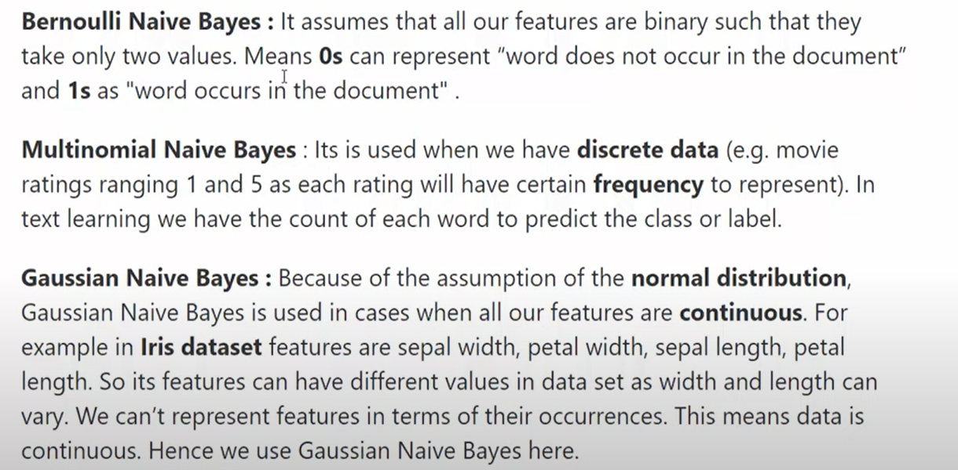
GridSearchCV is a method in machine learning used for hyperparameter tuning to improve model performance. It systematically searches through a predefined set of hyperparameters to find the optimal combination that maximizes model accuracy.
Here’s how to explain GridSearchCV from an interview perspective:
- Objective: The goal of GridSearchCV is to automate the process of finding the best hyperparameters for a model by trying multiple combinations and identifying which setup performs best on a given dataset.
- How It Works:
  - Define the Hyperparameter Grid: Specify a grid of hyperparameters to explore. Each parameter can take on multiple values, and GridSearchCV will try each possible combination. For example, for a decision tree, you might try different values for maximum depth, minimum samples per leaf, or the criterion (e.g., gini or entropy).
  - Cross-Validation: For each hyperparameter combination, GridSearchCV applies K-Fold Cross Validation (often 5 or 10 folds). It trains and tests the model K times on different splits of the data and calculates an average score.
  - Evaluate and Select: After testing all combinations, GridSearchCV picks the combination with the best average score across the cross-validation folds, thus selecting the hyperparameters that best generalize to unseen data.
- Why GridSearchCV:
  - Thorough Search: Unlike manual hyperparameter tuning, which might miss optimal settings, GridSearchCV tests all possible combinations, ensuring a comprehensive search within the defined grid.
  - Objective and Automated: By running systematic cross-validation, GridSearchCV removes bias from manual tuning and provides a data-driven way to optimize hyperparameters.
- Advantages:
  - Automated and Reliable: By combining cross-validation and grid search, it produces reliable estimates of the best hyperparameters.
  - Parallel Processing: Many libraries (like scikit-learn) allow GridSearchCV to run on multiple cores, speeding up the search process.
- Limitations:
  - Computationally Intensive: As the number of hyperparameters and possible values increases, GridSearchCV can become computationally expensive. Each parameter added to the grid exponentially increases the number of combinations, especially with high-dimensional data.
  - Not Always Optimal for Large Grids: When there are many hyperparameters to explore, RandomizedSearchCV might be preferred as it randomly samples combinations, potentially saving time while still finding good hyperparameter settings.
- Example:
  - For a Random Forest model, you might use GridSearchCV to explore hyperparameters like the number of trees (n_estimators), maximum depth (max_depth), and minimum samples per leaf (min_samples_leaf). GridSearchCV will evaluate each combination across cross-validation folds, selecting the one that maximizes performance (e.g., accuracy or F1-score).
- Implementation in Python:
  - In libraries like scikit-learn, implementing GridSearchCV is straightforward:
python
Copy code
from sklearn.model_selection import GridSearchCV
from sklearn.ensemble import RandomForestClassifier

# Define the model and parameter grid
model = RandomForestClassifier()
param_grid = {
'n_estimators': [50, 100, 200],
'max_depth': [None, 10, 20, 30],
'min_samples_leaf': [1, 2, 4]
}

# Initialize GridSearchCV
grid_search = GridSearchCV(estimator=model, param_grid=param_grid, cv=5, scoring='accuracy')
grid_search.fit(X_train, y_train)

# Get best parameters and score
best_params = grid_search.best_params_
best_score = grid_search.best_score_
- Applications:
  - GridSearchCV is widely used in model selection, parameter tuning, and validating model robustness. It’s particularly beneficial when fine-tuning models with critical hyperparameters, such as SVMs, Random Forests, and neural networks.
In summary, GridSearchCV is a powerful tool for automating hyperparameter tuning, ensuring that the model is optimized for accuracy and generalizability by systematically searching for the best settings in a defined parameter grid.
RandomizedSearchCV is a hyperparameter tuning technique similar to GridSearchCV, but instead of exhaustively searching through all possible parameter combinations, it randomly samples a fixed number of combinations from the parameter space. This makes it more efficient, especially when there are many hyperparameters or a large range of values to explore.
Here’s how to explain RandomizedSearchCV from an interview perspective:
- Objective: RandomizedSearchCV aims to find the best hyperparameters for a model by sampling and testing a random subset of all possible parameter combinations, trading a bit of thoroughness for much faster results.
- How It Works:
  - Define the Parameter Distributions: Instead of defining a fixed grid of values for each hyperparameter, you define a distribution or a list of possible values for each parameter. This distribution can be uniform, normal, or a list of specified values.
  - Random Sampling: RandomizedSearchCV randomly selects a predefined number of parameter combinations from these distributions (not all combinations), and evaluates the model for each combination.
  - Cross-Validation: Like GridSearchCV, RandomizedSearchCV uses cross-validation to test each sampled combination of hyperparameters, typically using K-Fold Cross Validation.
  - Select Best Combination: After running all trials, RandomizedSearchCV returns the best combination of hyperparameters based on the cross-validation results.
- Advantages:
  - More Efficient: RandomizedSearchCV is faster than GridSearchCV because it doesn’t try every possible combination. Instead, it focuses on a subset, which can still yield good results in less time.
  - Effective with Large Parameter Spaces: Works well when there are many hyperparameters or a large range of values since it avoids exhaustive searching.
  - Flexible Search Space: Allows you to specify a continuous distribution (e.g., uniform or normal) instead of a fixed list of values, making it suitable for tuning hyperparameters over a large range.
- Limitations:
  - Random Sampling: While faster, it may miss the optimal combination since it doesn’t test all possible configurations.
  - Less Thorough than Grid Search: For smaller parameter grids where exhaustive search is feasible, GridSearchCV may yield slightly better results.
- Example:
  - Suppose you’re tuning a Random Forest model and want to try various values for n_estimators, max_depth, and min_samples_split. Instead of evaluating all combinations, RandomizedSearchCV can randomly sample combinations from these distributions. This is especially useful if you have a wide range of values (e.g., 50 to 500 trees for n_estimators).
- Implementation in Python:
  - Using scikit-learn, RandomizedSearchCV can be implemented as follows:
python
Copy code
from sklearn.model_selection import RandomizedSearchCV
from sklearn.ensemble import RandomForestClassifier
from scipy.stats import randint

# Define model and parameter distributions
model = RandomForestClassifier()
param_distributions = {
'n_estimators': randint(50, 200),
'max_depth': [None, 10, 20, 30, 40],
'min_samples_split': randint(2, 10),
}

# Initialize RandomizedSearchCV
random_search = RandomizedSearchCV(estimator=model, param_distributions=param_distributions, n_iter=10, cv=5, scoring='accuracy')
random_search.fit(X_train, y_train)

# Get best parameters and score
best_params = random_search.best_params_
best_score = random_search.best_score_
  - In this example, n_iter=10 indicates that it will try 10 random combinations from the parameter space.
- Applications:
  - RandomizedSearchCV is commonly used in situations where quick tuning is needed or when working with high-dimensional parameter spaces (e.g., complex models like Random Forests or deep neural networks).
In summary, RandomizedSearchCV provides a more efficient alternative to GridSearchCV by using random sampling to tune hyperparameters. It’s an excellent option when computational resources are limited or when the parameter space is large, making it ideal for rapid model tuning with good results.

Ensemble Learning is a machine learning technique that combines the predictions of multiple models to improve overall performance, accuracy, and robustness. One popular ensemble approach is Bagging (Bootstrap Aggregating), which is primarily used to reduce variance and prevent overfitting in complex models, such as decision trees.
Here’s how to explain Bagging from an interview perspective:

1. Objective of Bagging:
- Reduce Variance: Bagging aims to decrease the variance of models that are prone to overfitting by averaging out predictions, making the ensemble more stable and improving generalization on unseen data.
- Increase Accuracy: By combining predictions from multiple models, Bagging can boost accuracy compared to a single model.
2. How Bagging Works:
- Step 1: Bootstrap Sampling:
  - Create multiple subsets of the training data by randomly sampling with replacement. Each subset, or "bootstrap sample," is the same size as the original dataset but includes some repeated instances due to replacement.
- Step 2: Train Models on Bootstrap Samples:
  - A separate model (often the same type of model) is trained on each bootstrap sample independently. For example, if you use decision trees, you’ll train a tree on each sampled dataset.
- Step 3: Aggregate Predictions:
  - For classification tasks, combine predictions by majority voting (the class with the most votes across models is chosen).
  - For regression tasks, combine predictions by averaging the output of all models.
- Outcome: By aggregating multiple predictions, Bagging reduces variance and makes the final ensemble less sensitive to outliers or fluctuations in the training data.
3. Bagging vs. Simple Models:
- While a single model (like an individual decision tree) can be highly sensitive to changes in data (high variance), bagging mitigates this sensitivity. As each model is trained on a different subset of data, their errors tend to "cancel out" when predictions are averaged, creating a more robust overall prediction.
4. Advantages of Bagging:
- Reduces Overfitting: By averaging across multiple models, Bagging reduces the overfitting often seen with high-variance models like decision trees.
- Works Well with High-Variance Models: Bagging is especially effective with models like decision trees, where even slight changes in data can lead to different results.
- Parallelizable: Since each model is trained independently, Bagging can be parallelized for faster computation.
5. Limitations of Bagging:
- Not Effective for High-Bias Models: Bagging works well for high-variance models but does not help much with high-bias models like linear regression. For high-bias cases, Boosting (another ensemble technique) is often more effective.
- Large Computation and Memory Costs: Bagging requires training multiple models, which can be computationally intensive and memory-consuming for large datasets.
6. Example:
- Random Forest: Random Forest is one of the most popular examples of Bagging, where multiple decision trees are built on different bootstrap samples, and predictions are combined through majority voting (classification) or averaging (regression). Additionally, Random Forest introduces randomness by selecting only a subset of features for each tree, further enhancing its robustness.
7. Implementation:
- Bagging can be implemented using libraries like scikit-learn in Python:
python
Copy code
from sklearn.ensemble import BaggingClassifier
from sklearn.tree import DecisionTreeClassifier
from sklearn.metrics import accuracy_score
from sklearn.model_selection import train_test_split

# Assume we have features X and labels y
X_train, X_test, y_train, y_test = train_test_split(X, y, test_size=0.3, random_state=42)

# Initialize Bagging with a base model (e.g., Decision Tree) and set number of estimators
bagging_model = BaggingClassifier(base_estimator=DecisionTreeClassifier(), n_estimators=10, random_state=42)
bagging_model.fit(X_train, y_train)

# Make predictions
y_pred = bagging_model.predict(X_test)
print("Bagging Accuracy:", accuracy_score(y_test, y_pred))
8. Applications:
- Credit Scoring: Bagging techniques like Random Forests are used to improve accuracy in credit scoring by combining predictions from multiple models.
- Customer Churn Prediction: Bagging is widely applied to stabilize predictions on customer churn, reducing variability for better predictions.
- Image and Object Recognition: Bagging techniques can handle high-dimensional datasets well, improving accuracy in image and object classification tasks.

In summary, Bagging is a powerful ensemble technique that uses bootstrap sampling and aggregation to reduce model variance, making it particularly effective for high-variance models like decision trees. By stabilizing predictions, Bagging improves generalization and provides a strong foundation for ensemble models like Random Forests.
The Extra Trees Classifier (Extremely Randomized Trees) and Random Forest Classifier are both ensemble learning methods based on decision trees and built using the Bagging technique. However, they have some key differences in how they build individual trees, particularly in the way they select splits. These differences affect their performance, computational efficiency, and ability to handle overfitting.
Key Differences Between Extra Trees Classifier and Random Forest Classifier:
- Tree Splitting Criterion:
  - Random Forest: In Random Forest, each tree is trained on a bootstrap sample of the data, and at each node, the algorithm chooses the best split from a random subset of features by evaluating information gain or Gini impurity. This randomness helps improve generalization while still aiming to find optimal splits.
  - Extra Trees: In Extra Trees, the algorithm goes a step further in introducing randomness by selecting split points randomly for each feature (within the selected subset of features) without trying to find the optimal split. This extra randomness helps reduce variance and speeds up training, as it avoids calculating the best split at each node.
- Use of Bootstrapping:
  - Random Forest: Uses bootstrap sampling, where each tree is trained on a sample drawn with replacement from the original dataset. This reduces correlation between trees, helping to create diverse predictions.
  - Extra Trees: By default, Extra Trees does not use bootstrapping (though it can be enabled). Each tree in Extra Trees is trained on the entire original dataset instead of bootstrap samples, which also reduces variance but differs in approach.
- Model Complexity and Overfitting:
  - Random Forest: Typically more accurate in classification tasks, Random Forests are less likely to overfit than Extra Trees in cases with complex data, as they consider optimal splits even with randomness.
  - Extra Trees: Due to highly randomized splits, Extra Trees is often less prone to overfitting in high-dimensional or noisy data, as the randomized splits act as a form of regularization. However, they can sometimes underfit if too many splits are chosen randomly without relevance to the data's true structure.
- Computational Efficiency:
  - Random Forest: Requires more computational power since it searches for the optimal split at each node, which involves calculating metrics like Gini impurity or information gain multiple times.
  - Extra Trees: More computationally efficient since it chooses split points randomly, avoiding the need to calculate optimal splits, which speeds up training, especially with high-dimensional data.
- Performance and Generalization:
  - Random Forest: Typically achieves better performance on many datasets due to its more systematic approach to finding splits, particularly in cases where there are clear and important patterns in the data.
  - Extra Trees: Often achieves slightly lower accuracy but with faster computation times. It can be advantageous when you need quick results or when dealing with high-dimensional or highly noisy datasets.
Example Comparison in Python:
Here’s a sample code to train and compare both classifiers using scikit-learn:
python
Copy code
from sklearn.ensemble import RandomForestClassifier, ExtraTreesClassifier
from sklearn.model_selection import train_test_split
from sklearn.metrics import accuracy_score

# Assume X and y are the feature matrix and target labels
X_train, X_test, y_train, y_test = train_test_split(X, y, test_size=0.3, random_state=42)

# Initialize and train the models
rf_model = RandomForestClassifier(n_estimators=100, random_state=42)
et_model = ExtraTreesClassifier(n_estimators=100, random_state=42)

rf_model.fit(X_train, y_train)
et_model.fit(X_train, y_train)

# Make predictions and evaluate accuracy
rf_pred = rf_model.predict(X_test)
et_pred = et_model.predict(X_test)

print("Random Forest Accuracy:", accuracy_score(y_test, rf_pred))
print("Extra Trees Accuracy:", accuracy_score(y_test, et_pred))
Summary Table:
Feature | Random Forest | Extra Trees
Splitting Criterion | Best split based on criteria like Gini impurity | Random split without evaluating best split
Bootstrapping | Uses bootstrapping (sample with replacement) | Default: No bootstrapping
Tendency to Overfit | Less prone to overfitting | Reduced tendency to overfit (more regularization)
Computation Time | Higher due to optimal split search | Lower due to random splits
Use Case | When high accuracy is required | When computation speed or regularization is critical

In summary, Random Forest is a more controlled approach, balancing accuracy and generalization, while Extra Trees introduces additional randomness, making it faster and often more robust against noise but potentially less accurate.
The Gradient Boosting Classifier is an ensemble machine learning technique that builds a strong predictive model by combining the strengths of many weak learners, typically decision trees. Unlike bagging methods, where multiple models are trained independently (e.g., Random Forest), Gradient Boosting is a sequential process, where each new model tries to correct the errors made by the previous models.
Here’s how to explain Gradient Boosting Classifier from an interview perspective:

1. Objective of Gradient Boosting:
- Reduce Bias and Improve Accuracy: Gradient Boosting aims to create a highly accurate model by sequentially improving weak models. Each model in the sequence corrects the errors of the previous one.
- Minimize the Loss Function: Gradient Boosting optimizes a loss function by adding models that best correct the errors of prior models, where the loss function measures how well the model predictions match the actual labels.
2. How Gradient Boosting Works:
- Step 1: Initialize with a Weak Model: Gradient Boosting starts with an initial prediction, usually a weak model (e.g., a shallow decision tree), which might have high bias.
- Step 2: Calculate Residuals: The residuals (errors) between the model's predictions and the actual values are calculated. These residuals represent the "directions" the model needs to improve upon.
- Step 3: Fit New Models to Residuals: A new model is trained to predict these residuals, essentially learning the errors made by the prior model. In each iteration, the new model is added to the ensemble and helps correct previous errors.
- Step 4: Update Predictions: The predictions from all models are combined (added) to generate the final prediction. Each model is typically weighted by a learning rate, which controls how much each new model impacts the overall prediction.
- Repeat: This process is repeated for a specified number of iterations, or until further improvements are minimal.
3. Key Components:
- Loss Function: Defines the type of problem (e.g., cross-entropy loss for classification, mean squared error for regression) and provides a target for optimization.
- Learning Rate: Controls how much each new model contributes to the final prediction. A lower learning rate typically requires more iterations but can result in better generalization.
- Number of Estimators: Specifies the number of boosting rounds (i.e., the number of trees to be built). More estimators can improve accuracy but may lead to overfitting.
4. Advantages of Gradient Boosting:
- High Accuracy: Gradient Boosting is known for achieving high predictive accuracy, especially on complex datasets.
- Flexibility with Different Loss Functions: Gradient Boosting can handle various loss functions, making it suitable for different types of problems (e.g., classification, regression).
- Built-in Feature Importance: It can provide insights into feature importance, helping with feature selection and model interpretability.
5. Disadvantages of Gradient Boosting:
- Prone to Overfitting: Gradient Boosting can overfit if not properly tuned, especially with a high number of trees or too deep trees.
- Computationally Intensive: The sequential nature of Gradient Boosting can make it slower to train compared to parallel methods like Random Forest.
- Sensitive to Noise: Gradient Boosting is sensitive to outliers and noisy data, as each model attempts to correct previous errors, potentially amplifying noise.
6. Popular Gradient Boosting Variants:
- XGBoost (Extreme Gradient Boosting): A highly optimized version of Gradient Boosting with features like regularization, which reduces overfitting, and parallel processing, making it faster.
- LightGBM: Optimized for speed and efficiency, especially on large datasets, by growing trees leaf-wise instead of level-wise.
- CatBoost: Designed to handle categorical data directly without needing to one-hot encode, making it fast and effective for datasets with many categorical features.
7. Example of Gradient Boosting in Python:
Using GradientBoostingClassifier from scikit-learn, here’s an example:
python
Copy code
from sklearn.ensemble import GradientBoostingClassifier
from sklearn.model_selection import train_test_split
from sklearn.metrics import accuracy_score

# Assume X and y are the feature matrix and target labels
X_train, X_test, y_train, y_test = train_test_split(X, y, test_size=0.3, random_state=42)

# Initialize the Gradient Boosting model with common parameters
gb_model = GradientBoostingClassifier(n_estimators=100, learning_rate=0.1, max_depth=3, random_state=42)
gb_model.fit(X_train, y_train)

# Make predictions and evaluate accuracy
y_pred = gb_model.predict(X_test)
print("Gradient Boosting Accuracy:", accuracy_score(y_test, y_pred))
8. Applications of Gradient Boosting:
- Finance: Used for credit scoring, risk assessment, and fraud detection due to its high accuracy in classification tasks.
- Healthcare: Applied in predicting disease outcomes and patient risk, as it can handle complex relationships between features.
- Marketing: Used for customer segmentation and churn prediction, where accurate predictions are critical.

Summary:
Gradient Boosting Classifier is a powerful, sequential ensemble technique that iteratively builds models to correct the errors of previous models, achieving high accuracy by optimizing a loss function. It’s effective for complex datasets but requires careful tuning to avoid overfitting, and it’s computationally more intensive than other methods like bagging-based ensembles.
Oversampling is a technique used to address class imbalance in a dataset, where one class is significantly underrepresented compared to another. In classification tasks, this imbalance can lead to biased models that perform well for the majority class but poorly for the minority class. Oversampling helps mitigate this issue by increasing the number of samples in the minority class to balance the class distribution.
Here’s how to explain Oversampling from an interview perspective:

1. Purpose of Oversampling:
- Handle Class Imbalance: Oversampling is used when you have imbalanced classes (e.g., fraud detection where "fraud" cases are rare).
- Improve Model Performance: By balancing the dataset, oversampling helps models learn the characteristics of the minority class more effectively, leading to improved performance, especially on minority class predictions.
2. How Oversampling Works:
- Replication of Minority Samples: The most straightforward form of oversampling involves replicating existing instances of the minority class until the dataset is balanced. However, this can lead to overfitting, as the model may simply memorize these repeated instances.
- Synthetic Data Generation (SMOTE): A more advanced approach called SMOTE (Synthetic Minority Over-sampling Technique) generates synthetic samples by interpolating between existing minority class samples. This creates new, unique samples rather than simply duplicating them, which helps to reduce the risk of overfitting.
3. Common Oversampling Techniques:
- Random Oversampling: Randomly duplicates samples from the minority class to balance the classes. This is simple to implement but can cause overfitting if done excessively.
- SMOTE: Synthesizes new samples by creating instances along the line segments between minority class samples. This increases diversity within the minority class without mere repetition, improving generalization.
- ADASYN (Adaptive Synthetic Sampling): Similar to SMOTE but focuses on generating synthetic samples for minority class samples that are harder to classify, helping the model learn from these difficult cases.
4. Advantages of Oversampling:
- Improved Model Balance: By equalizing the class distribution, oversampling prevents the model from ignoring the minority class, leading to improved recall and F1-score.
- Better Minority Class Representation: With more minority class instances, the model can learn to better generalize to minority class patterns, making it effective for tasks where the minority class is crucial (e.g., rare disease detection).
5. Disadvantages of Oversampling:
- Risk of Overfitting: Random oversampling can lead to overfitting if the minority class samples are simply duplicated. The model may memorize these samples rather than generalize from them.
- Increased Computation: With more samples, training times increase, which can be computationally intensive, especially for large datasets.
6. Implementation Example with SMOTE:
In Python, you can use the imblearn library to apply SMOTE:
python
Copy code
from imblearn.over_sampling import SMOTE
from sklearn.model_selection import train_test_split
from sklearn.ensemble import RandomForestClassifier
from sklearn.metrics import classification_report

# Assume X and y are the feature matrix and target labels
X_train, X_test, y_train, y_test = train_test_split(X, y, test_size=0.3, random_state=42)

# Apply SMOTE to oversample the minority class in the training set
smote = SMOTE(random_state=42)
X_resampled, y_resampled = smote.fit_resample(X_train, y_train)

# Train a classifier on the resampled data
clf = RandomForestClassifier(random_state=42)
clf.fit(X_resampled, y_resampled)

# Evaluate the model
y_pred = clf.predict(X_test)
print(classification_report(y_test, y_pred))
7. When to Use Oversampling:
- Binary Classification: Oversampling is commonly used in binary classification when one class significantly outnumbers the other, such as fraud detection, medical diagnosis, or churn prediction.
- Before Model Training: Oversampling is applied to the training dataset to balance the classes, not to the test set.

Summary:
Oversampling is a data preprocessing technique used to handle class imbalance by increasing the number of instances in the minority class, either by replicating existing instances or generating synthetic data. It helps improve model performance for the minority class, with SMOTE being one of the most effective methods. While oversampling enhances minority class learning, careful implementation is needed to avoid overfitting and increased computational cost.

